**UX documentation**

**Feedback in online training**

At first, we will see the initial screen with 3 columns: *Left, Idle, Right:*

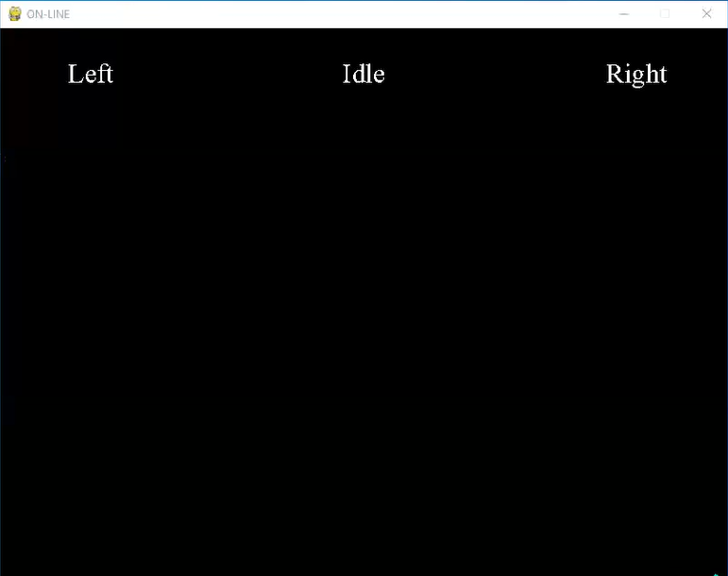

We are online training the user and when our classify predicts one of the tags, a picture of a moving hand has been adding to the appropriate column. We can see an example of our classify predicts twice of “Imagine moving a right hand” and put two pictures on this column.

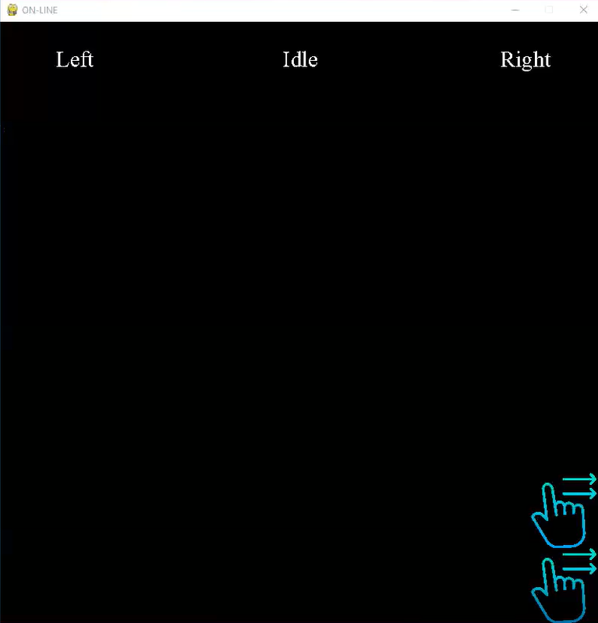

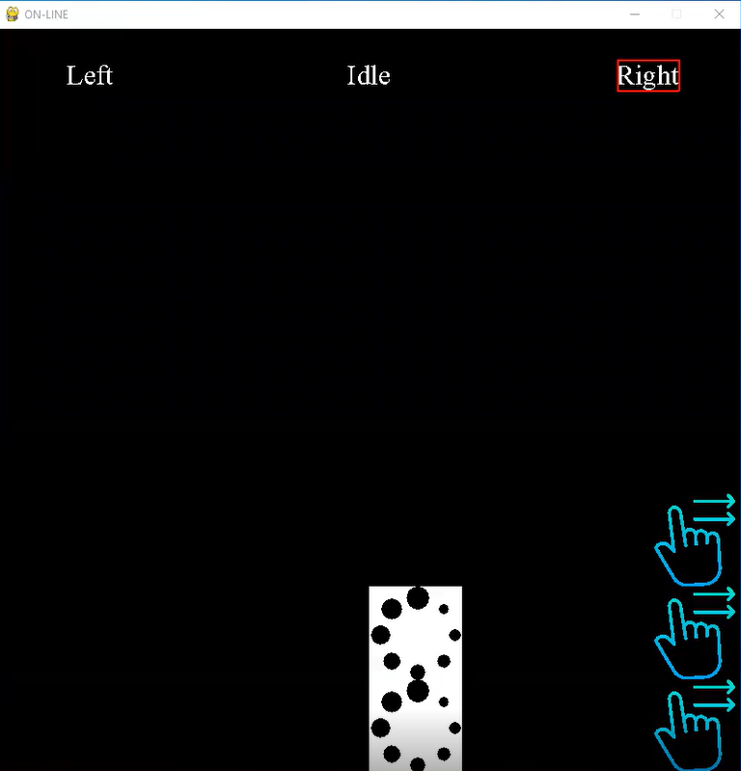 After 5 predictions, if most of the votes are “Right” the next screen will be “calling for help”.

In this example, we got 2 votes for “Idle” and 3 votes for “Right” so the final decision for our classify is “Right”. (We can see a red square on the chosen tag).

If the right has been chosen, we will see the next screen and we will get sound of an alarm.



If the left has been chosen, the next screen will be identical to the initial screen except for the names of the columns will change to “Yes”, “No”, and “Idle”.

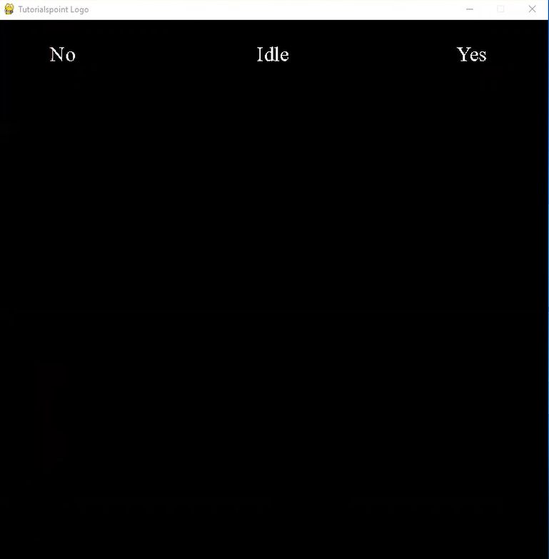

For a selection of the tag *“No”* the classify needs to predict “Imagine moving a left hand”, and for *“Yes”* “Imagine moving a right hand”.

If after 5 tries most of the prediction will be “Imagine moving a left hand” the next window will be with a figure of “NO”, if most of them will be “Imagine moving a left hand” then figure with “YES” and otherwise (Idle) the next screen will be an initial window (with columns of “left”, “Idle”, “Right”).



**Feedback in offline training**

In the training phase, we create a window with a red square.

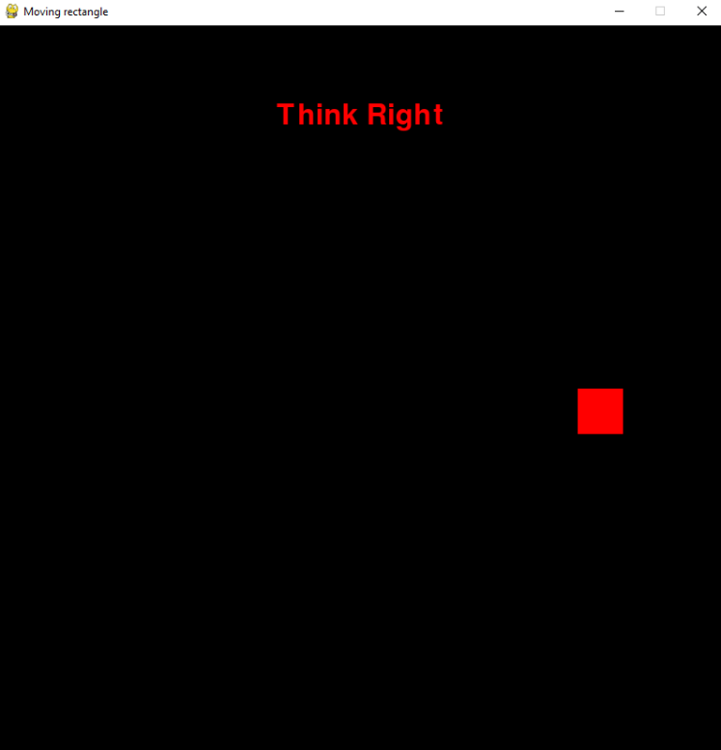We are guiding the user according to the sentence “Think Left” (meaning “Imagine moving a left hand”) or “Think Right”. The square is moving according to the prediction of the classifier.

